Non-Recursive Query

🔄 What is a Non-Recursive DNS Query?
# Source: AI Source: Provided by: [Data Path: Persons Table -> ID Column: 1, Name_En Column: Motasem Essam] -> From: [ChatGPT] on [1/18/2026]
A Non-Recursive Query is a DNS request where the client asks a DNS server only if it already knows the answer — the server will respond only if the domain is already in its cache or zone file. It does not perform any further lookups or contact other DNS servers.
🧠 It’s like asking: “Do you know the answer? Yes or no — don’t go find it.”

📌 Key Characteristics
# Source: AI Source: Provided by: [Data Path: Persons Table -> ID Column: 1, Name_En Column: Motasem Essam] -> From: [ChatGPT] on [1/18/2026]
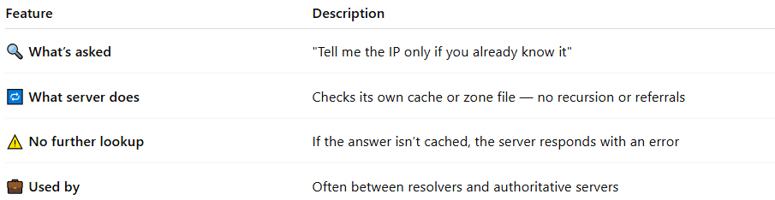

Feature | Description
🔍 What’s asked | "Tell me the IP only if you already know it"
🔁 What server does | Checks its own cache or zone file — no recursion or referrals
⚠️ No further lookup | If the answer isn’t cached, the server responds with an error
💼 Used by | Often between resolvers and authoritative servers

🧭 When Is a Non-Recursive Query Used?
# Source: AI Source: Provided by: [Data Path: Persons Table -> ID Column: 1, Name_En Column: Motasem Essam] -> From: [ChatGPT] on [1/18/2026]
- ✅ When a DNS resolver queries an authoritative server for a known domain.
- ✅ When a DNS server is configured not to allow recursion (common for security).
- ✅ When the client itself wants more control over the query process.

🧪 Example
# Source: AI Source: Provided by: [Data Path: Persons Table -> ID Column: 1, Name_En Column: Motasem Essam] -> From: [ChatGPT] on [1/18/2026]
If a DNS resolver queries a root server with:
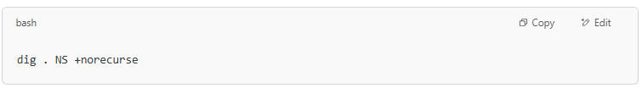
dig . NS +norecurse

The root server will not go fetch info from other servers — it’ll only return what it knows (e.g., the list of TLD servers).

📊 Recursive vs Iterative vs Non-Recursive
# Source: AI Source: Provided by: [Data Path: Persons Table -> ID Column: 1, Name_En Column: Motasem Essam] -> From: [ChatGPT] on [1/18/2026]
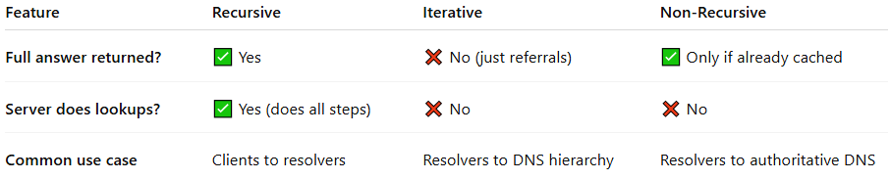

Feature | Recursive | Iterative | Non-Recursive
Full answer returned? | ✅ Yes | ❌ No (just referrals) | ✅ Only if already cached
Server does lookups? | ✅ Yes (does all steps) | ❌ No | ❌ No
Common use case | Clients to resolvers | Resolvers to DNS hierarchy | Resolvers to authoritative DNS

✅ Summary
# Source: AI Source: Provided by: [Data Path: Persons Table -> ID Column: 1, Name_En Column: Motasem Essam] -> From: [ChatGPT] on [1/18/2026]

Non-Recursive Query = “Answer only if you already know”
🔎 No recursive resolution — no contacting other servers
⚙️ Used by resolvers or servers with cached data
🚫 Fast, simple, secure — but only works if info is available

